Project Documentation
1. Introduction

Project Title: Script-Controlled ACL - Restrict Record Access Based on Field Value Team Members:
Name | Role
Ragul M | Team Leader
Shawn Samuel H | Member 1
Shirapthi Nath L H | Member 2
Vishwa G | Member 3
Pughazhendhi A | Member 4

2.Project Overview
Features:
phone and description fields.
- Custom roles bb1 (read), bb2 (create), bb3 (write) and bb4 (delete).
- READ ACL with data condition Branch is EEE and an advanced script.
- Separate CREATE, WRITE and DELETE ACLs.
- Admin override so administrators see all records.

3.Architecture
- Frontend (React equivalent): The ServiceNow platform UI. Users work in the standard list and form views of the Institution Details table. The UI adapts to the user's ACLs: rows are filtered, the New button appears only with bb2, fields are editable only with bb3 and Delete appears only with bb4.
- Backend (Node.js and Express.js equivalent): ServiceNow server-side logic. Each request is checked by the matching ACL, using the role requirement, the data condition and the advanced script (server-side JavaScript with gs.hasRole()).
- Database (MongoDB equivalent): The ServiceNow database table u_institution_details.

Field | Type | Notes
Student Roll Number | Auto number | Default INS000xxxx
Student Name | Reference (User)
Faculty Name | Reference (User)
Branch | Choice | ECE, EEE, CSE
Email | String
Phone Number | String
Description | Multi-line string | Editable with bb3

4.Setup Instructions
Prerequisites:
- A ServiceNow instance (for example a Personal Developer Instance) and a login with admin access.
- Ability to elevate to the security_admin role, needed to create ACLs.
- A modern web browser. No local software, Node.js or MongoDB installation is needed.
Installation (no cloning or environment variables are needed):
- Sign in to the instance as admin.
- Create the user EEE User (User Administration > Users).
- Create roles bb1, bb2, bb3, bb4 and assign them to EEE User.
- Create the table u_institution_details and add its fields, then enter sample records for ECE, EEE and CSE.
- Elevate the security_admin role, then create the READ, CREATE, WRITE and DELETE ACLs (System Security > Access Control (ACL)).
- Capture the work in an update set (the lab used the update set "ACL Project [Global]") so it can be moved to another instance.

5.Folder Structure
Method | Endpoint | Purpose
GET | /api/now/table/u_institution_details | List records the caller may read

Client: Not applicable. There are no React source files; the UI is provided by the platform.
Server: Not applicable. There is no Node.js code; the configuration is stored as ServiceNow records:

Item | Where it lives
Users and roles | User Administration > Users, Roles
Table and fields | System Definition > Tables
ACLs and script | System Security > Access Control (ACL)
Packaging | Update set "ACL Project [Global]", Global scope

6.Running the Application
There are no npm start commands. To run and test the project:
- Frontend: sign in to the instance and open the list by entering u_institution_details.list in the All menu filter.
- Backend: nothing to start; the ACLs run automatically on every request.
- Test as different users with Impersonate user (EEE User, a user without the roles, and Admin).

7.API Documentation
This project does not add custom endpoints. ServiceNow's built-in REST Table API exposes the table, and the configured ACLs also apply to API requests. The examples are illustrative; verify the exact field names in the target instance.
Method | Endpoint | Purpose
GET | /api/now/table/u_institution_details/{sys_id} | Get one record
POST | /api/now/table/u_institution_details | Create a record (needs bb2)
PATCH | /api/now/table/u_institution_details/{sys_id} | Update a record (needs bb3)
DELETE | /api/now/table/u_institution_details/{sys_id} | Delete a record (needs bb4)
Parameters: sysparm_query (for example u_branch=EEE), sysparm_limit, sysparm_fields.
Example response for GET (illustrative), as a user with bb1:
{ "result": [
{ "sys_id": "",
"u_student_roll_number": "INS0001007",
"u_branch": "EEE",
"u_email": "saiguna@gmail.com",
"u_phone_number": "9090898765" } ] }
A user without the required role receives an empty result list or an access-denied error, depending on the ACL that fails.

8.Authentication
- Authentication: Users sign in to the ServiceNow instance, which creates a session. API clients authenticate with their own credentials (for example basic auth or OAuth).
- Authorization: Roles bb1 to bb4 control each operation. For every request ServiceNow evaluates the matching ACL: the role requirement, the data condition (Branch is EEE) and the advanced script.
- Admin handling: Admins see all records through the script check and the Admin overrides setting.
- Elevated privileges: Creating ACLs requires elevating the security_admin role for the session.
- Testing identities: The Impersonate user feature switches between EEE User, a user without the roles, and Admin.

9.User Interface

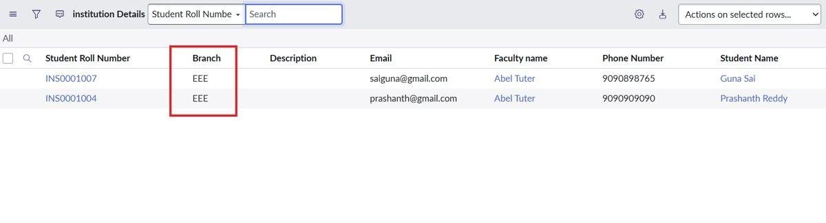
User with bb1 role: only EEE records are listed
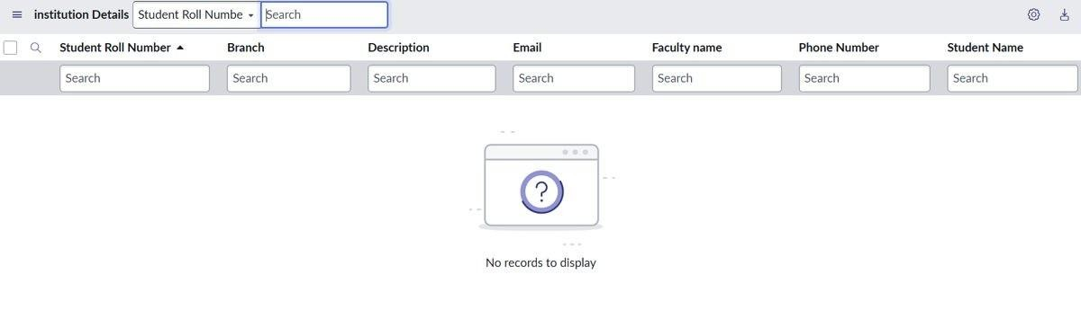
User without the role: no records are displayed
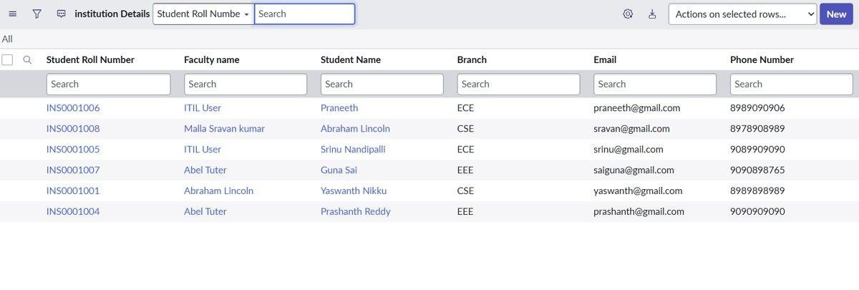
Admin: all records are displayed
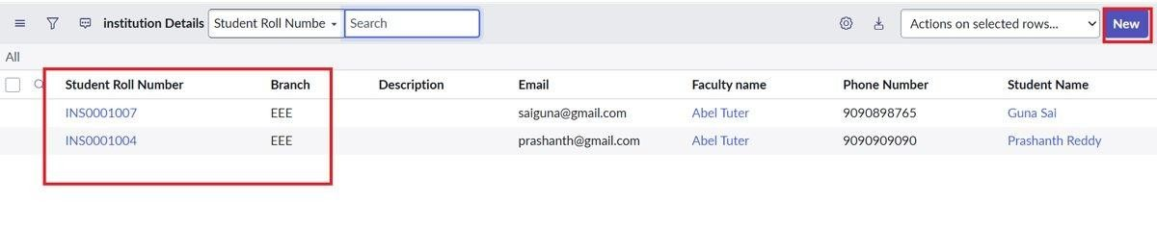
User with bb1 and bb2: EEE records with the New button

10.Testing
Tools: ServiceNow user impersonation, list views and the ACL forms.

Test | Result
bb1 user sees only EEE records (2 of 6) | Pass
User without the role sees no records | Pass
Admin sees all 6 records | Pass
bb1 + bb2: New button shown | Pass
Test | Result
bb1 to bb3: Description edited | Pass
bb1 to bb4: Delete option and confirmation shown | Pass
Negative checks for bb2, bb3, bb4 (without the role) | Pending
Performance: load time, concurrency, bulk load | Pending

11.Screenshots or Demo

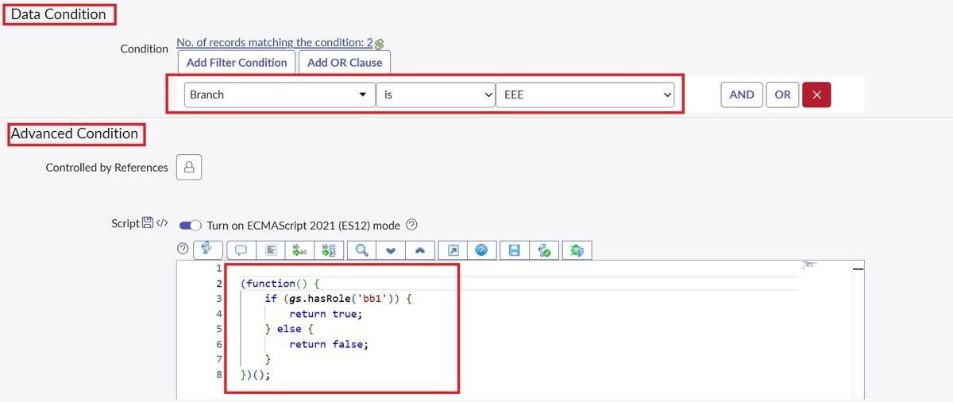
READ ACL: data condition (Branch is EEE) and script
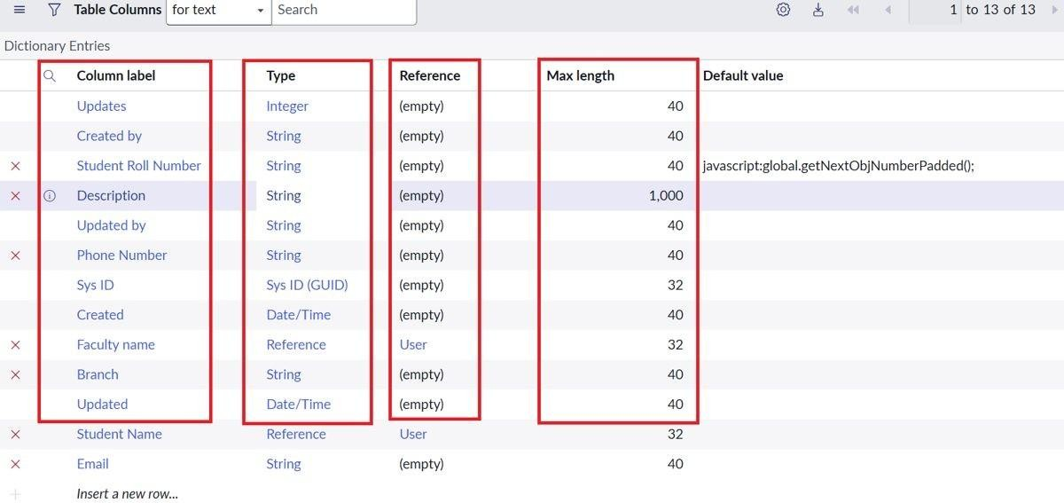
Table columns of u_institution_details
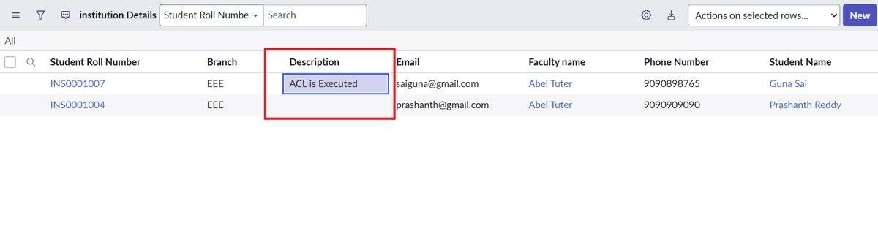
bb3 user editing the Description field
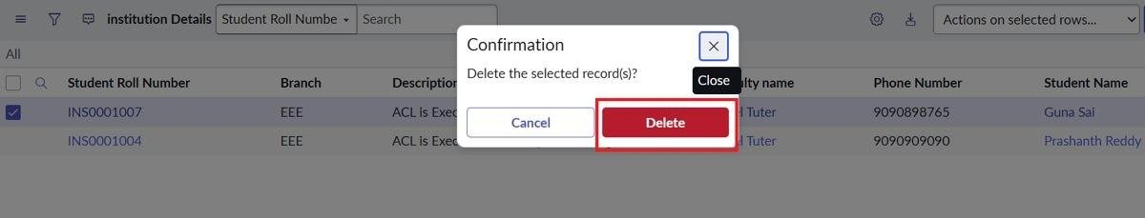 bb4 user deleting a record (confirmation)
Demo link:

12.Known Issues

ID | Issue | Severity
BG-001 | Branch appears as a String field in the columns screenshot, but the instructions say Choice (ECE, EEE, CSE). | Low
BG-002 | The READ ACL script in the screenshot checks only bb1, while the instructions also include an admin check. Admins still see all records because of Admin overrides. | Low
BG-003 | The ACL logic is tied to EEE and bb1; other branches are not yet covered. | Low

13.Future Enhancements

- Add roles and conditions for ECE and CSE.
- Add field-level ACLs for Email and Phone Number.
- Use groups or a branch lookup instead of hard-coded roles.
- Extend the ACLs to Service Portal pages.
- Add automated tests, for example with ServiceNow's Automated Test Framework.

